***Updated: 27.12.2024.***

**01 INSTRUCTIONS FOR WRITING ARTICLES USING THE GIVEN FORM (Word)**

**NOTES:**

**- The Editorial Office provides professional copy editing and proofreading of articles in English as well as translations (and copy editing where applicable) of abstracts with key words into Spanish, Russian and Serbian.**

**- You need to submit the article in .docX format (Word 2010 or newer)!**

**Writing articles will be facilitated upon opening the window with the predefined text styles.**

**How to open the window with the predefined text styles**

Copy the Form from the site to your computer. Open the predefined styles so that they are visible on the right side of the screen following the steps:

in the Main Menu on the top click on:

Home – Styles (a small window below the option Change Styles)

(it is possible to enlarge the window):

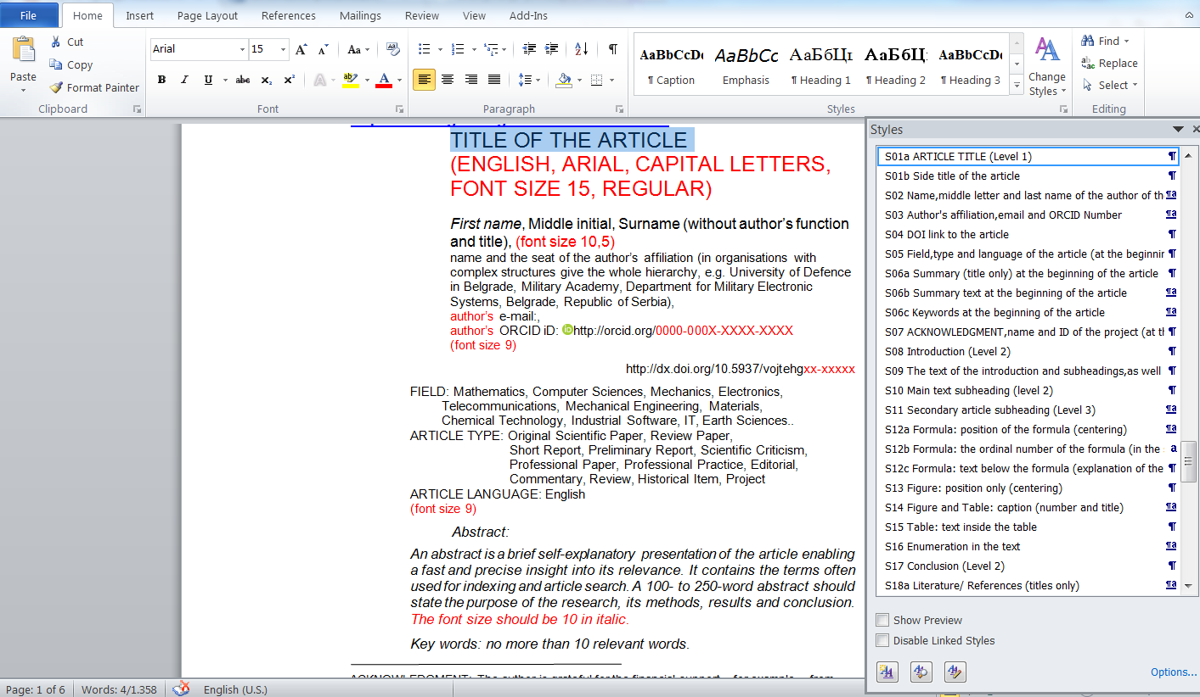

а) If the article text has not been already prepared:

– Type directly into the Form and, when typing is finished, select particular elements and click on the fields (from **S01** to **S24**) in the right-hand column referring to the selected elements (e.g. type the title, select/highlight it and click on **S01 TITLE** in the right-hand column thus obtaining the required format and style of the element in question).

b) If the article text has already been prepared:

– Copy the text into the Form separately, element by element: title, affiliation, introduction, headings, text, references, etc. in the following way: after copying each part of the text, select/highlight it and click on the field in the right-hand column referring to the selected part (e.g. when copying the title, select it and click on **S01 TITLE** in the right-hand column) thus obtaining the required format and style of the element in question. The fields in the right-hand column (from **S01** to **S24**) refer to all the elements in the article structure and they are given in order of their appearance in the article structure.

It is also possible to copy the complete article text into the Form and then to select particular elements separately (title, author’s affiliation… introduction, headings, text, references, etc.). After each text selection, click on the field in the right-hand column referring to the selected part; you will thus obtain the required format and style of the text element in question.

**If some other predefined styles besides the current ones appear in the right-hand column (e.g. from a previous form and alike), attention should be paid only on the current styles designated from S01 to S24.**

When formatting the text, i.e. using the **S01-S24** styles in text parts which include superscripts (e.g. *m3*, *km2*), subscripts (e.g. *x1*, *n1*), *italics*, footnotes1, etc. it is advisable to double check and correct the text if necessary since such fonts might not be recognized as exceptions in the chosen style.

**Review of the style designations by text parts:**

|  |  |  |  |
| --- | --- | --- | --- |
| **Style number** | **Број и назив стила на**  **српском** | **Номер и название стиля на русском языке** | **Number and name of the style in English** |
| **S01a** | S01a NASLOV ČLANKA (nivo 1) | S01a НАЗВАНИЕ СТАТЬИ (Уровень 1) | S01a ARTICLE TITLE (Level 1) |
| **S01b** | S01b Bočni naslov članka | S01b Боковое название статьи | S01b Side title of the article |
| **S02** | S02 Ime,srednje slovo i prezime autora članka na početku članka | S02 Название, средняя буква и фамилия автора статьи в начале статьи | S02 Name, middle letter and last name of the author of the article at the beginning of the article |
| **S03** | S03 Mesto rada autora,e-mail i ORCID broj autora | S03 Место работы автора, эл.почта и ORCID номер | S03 Author's affiliation, email and ORCID Number |
| **S04** | S04 DOI link članka | S04 DOI ссылка на статью | S04 DOI link to the article |
| **S05** | S05 Oblast,vrsta i jezik članka (na početku članka) | S05 Область, тип и язык статьи (в начале статьи) | S05 Field, type and language of the article (at the beginning of the article) |
| **S06a** | S06a Sažetak (samo naslov) na početku članka | S06a Резюме (только название) в начале статьи | S06a Summary (title only) at the beginning of the article |
| **S06b** | S06b Tekst sažetka na početku članka | S06б Текст резюме (только название) в начале статьи | S06b Summary text at the beginning of the article |
| **S06c** | S06c Ključne reči na početku članka | S06c Ключевые слова в начале статьи | S06c Keywords at the beginning of the article |
| **S07** | S07 ZAHVALNICA,naziv i oznaka projekta (u dnu prve strane ali ne u fusnoti) | S07 БЛАГОДАРНОСТЬ, название и обозначение проекта (внизу первой страницы, но не в сноске) | S07 ACKNOWLEDGMENT, name and ID of the project (at the bottom of the first page but not in a footnote) |
| **S08** | S08 Uvod (nivo 2) | S08 Введение (Уровень 2) | S08 Introduction (Level 2) |
| **S09** | **S09 Tekst uvoda i podnaslova,ujedno i tekst članka** | **S09 Текст введения и подзаголовков, а также текст статьи** | **S09 The text of the introduction and subheadings, as well as the text of the article** |
| **S10** | S10 Glavni podnaslov teksta (nivo 2) | S10 Основные тематические заглавия статьи (Уровень 2) | S10 Main text subheading (level 2) |
| **S11** | S11 Sporedni podnaslov članka (nivo 3) | S11 Тематические заглавия статьи (Уровень 3) | S11 Secondary article subheading (Level 3) |
| **S12a** | S12a Formula:pozicija formule (centriranje) | S12a Формула: положение формулы (центрирование) | S12a Formula: position of the formula (centering) |
| **S12b** | S12b Formula:redni broj formule (u maloj zagradi) | S12b Формула: порядковый номер формулы (в небольшой скобке) | S12b Formula: the ordinal number of the formula (in the small parenthesis) |
| **S12c** | S12c Formula:tekst ispod formule (objašnjenje formule) | S12c Формула: текст ниже формулы (объяснение формулы) | S12c Formula: text below the formula (explanation of the formula) |
| **S13** | S13 Slika:samo pozicija (centriranje) | S13 Рисунок: только положение (центрирование) | S13 Figure: position only (centering) |
| **S14** | S14 Slika i Tabela: potpis (broj i naziv) | S14 Рисунок и таблица: подпись (номер и название) | S14 Figure and Table: caption (number and title) |
| **S15** | S15 Tabela:tekst unutar tabele | S15 Таблица: текст внутри таблицы | S15 Table: text inside the table |
| **S16** | S16 Nabrajanje u tekstu | S16 Перечисление в тексте | S16 Enumeration in the text |
| **S17** | S17 Zaključak (nivo 2) | S17 Заключение (Уровень 2) | S17 Conclusion (Level 2) |
| **S18a** | S18a Literatura/Reference (samo naslov) | S18a Литература (только название) | S18a Literature/ References (titles only) |
| **S18b** | S18b Navođenje literature | S18b Написание литературы | S18b Writing literature |
| **S19** | S19 Naslov članka u rezimeima na drugim jezicima (na kraju članka) | S19 Название статьи в резюме на других языках (в конце статьи) | S19 Title of the article in the summaries in other languages (at the end of the article) |
| **S20** | S20 Autori, oblast i vrsta članka u rezimeu na stranom jeziku (na kraju članka) | S20 Авторы, область и тип статьи в резюме на других языках (в конце статьи) | S20 Authors, article field and type in the summaries in other languages (at the end of the article) |
| **S21a** | S21a Sažetak (samo naslov) u rezimeima na drugim jezicima (na kraju članka) | S21a Резюме (только название) в резюме на других языках (в конце статьи) | S21a Summary (title only) in the summaries in other languages (at the end of the article) |
| **S21b** | S21b Sažetak:tekst sažetka u rezimeima na drugim jezicima (na kraju članka) | S21b Резюме: текст резюме в резюме на других языках (в конце статьи) | S21b Summary: summary text in the summaries in other languages (at the end of the article) |
| **S21c** | S21c Ključne reči u rezimeima na drugim jezicima (na kraju članka) | S21c Ключевые слова в резюме на других языках (в конце статьи) | S21c Keywords in the summaries in other languages (at the end of the article) |
| **S22** | S22 Datumi prijema,dostavljanja ispravki i konačnog prihvatanja članka | S22 Даты получения, внесения исправлений и окончательного принятия статьи | S22 Dates of submission, delivery of corrections and final acceptance of the article |
| **S23** | S23 Klauzula o otvorenom pristupu i CCBY licenci članka | S23 Заявление об открытом доступе и лицензия CCBY | S23 Clause on Open Access and CCBY License of the Article |
| **S24** | S24 Amblem CCBY licence | S24 Логотип CCBY | S24 CCBY Logo |
| Auto-matically defined style | Footnote Text | Footnote Text | Footnote Text |

**Pay particular attention to define the letter size and fonts for headings and subheadings (which are not enumerated) in accordance with the Form.**

You are kindly asked to edit the article CAREFULLY and to adhere to the following guidelines WITHOUT EXCEPTION:

1. The layout of the article should conform FULLY with the Article Writing Form <http://www.vtg.mod.gov.rs/article-form.html> (DO NOT CHANGE MARGINS AND SIZE OF LETTERS of headings and subheadings defined by the Form, figures should fit the existing margins as in print preview, etc.)

2. The abstract should be written following 02 GUIDANCE ON WRITING ABSTRACTS on the page <http://www.vtg.mod.gov.rs/article-form.html>.

3. IMPORTANT NOTICE: **The citation standard adopted by the Military Technical Courier is the Harvard Style Manual. When citing, please follow the instructions on the Instructions for Harvard Style Manual page,** <http://www.vtg.mod.gov.rs/instructions-for-harvard-style-manual-1.html>**.**

**In the article text, BE SURE you quote ALL REFERENCES listed in the References!**

**DO NOT refer to the literature in the abstract and conclusion of the article!**

4. It is of particular importance to write all the formulas within the article using Insert – Equation. They should not be copied from e.g. a PDF file.

5. When submitting a manuscript in English which is not your mother tongue, if you are not sure about the quality of the translation and/or you have used online translators, please add a version of your COMPLETE manuscript in your mother tongue (Russian or Serbian) after the text in English in the same database so that the copy editor can compare the texts.

English translations are always copy edited which means that your translation will be accurate even if you have used online translators such as Google.

**6. In articles in English language, decimal numbers should be written with a decimal point, not a comma (e.g. it is correct to write 0.5, incorrect to write 0,5).**

7. The length of an article should be approximately 16 pages (it is acceptable to write less while 24 should be the maximum number of pages written in the given form)!

Thank you for your understanding.

Best regards,

Еditor of the Military Technical Courier

Nebojša Gaćeša

<http://www.vtg.mod.gov.rs/contact.html>